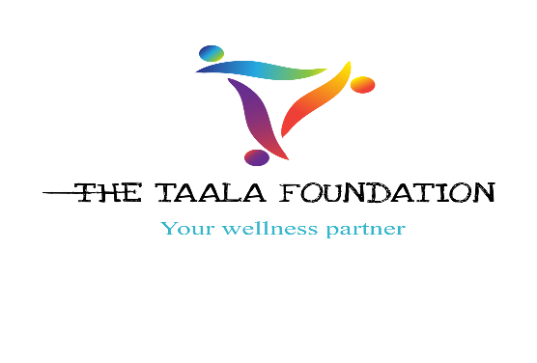

NETW

SEXUAL RIGHTS LITIGATION NETWORK
MEMBERSHIP APPLICATION AND ASSESSMENT FORM

The purpose of this form is to enable Taala Foundation and ISLA to understand the nature of your work as well as your understanding of strategic litigation and sexual rights. This will enable us to assess your suitability to be part of the SXLN network chapter in Uganda. Interested individuals and organisations are invited to complete this form with as much detail as possible.

BACKGROUND

The Taala Foundation is a registered entity working to bridge the gap in access to wellness support for gender and sexual diverse people in Uganda primarily through Mental Health Promotion and Education. We view wellness as the evolving process of achieving physical, mental, social, intellectual, spiritual, and occupational wellbeing; and thus, we develop our robust programs recognizing those various aspects of wellness. Overall, our work aims at fostering greater levels of wellbeing, dignity, tolerance, respect, and acceptance for gender and sexual diverse people within the broader society.

The Initiative for Strategic Litigation in Africa (ISLA) is a Pan-African and feminist initiative which engages the rule of law within African domestic and regional courts to advance sexual and women’s human rights. We believe that strategic litigation can reframe understandings of entitlements before the law, challenge legal discourse on human rights violations, hold States and other duty bearers accountable to violations of human rights (especially those grounded in gender and sexualities), and develop new norms. Our work is also based on the belief that strategic litigation is a powerful tool for social change because it has the capacity to work in multidimensional ways, both within a given context and, critically, across contexts. We highlight positive developments and emphasise cross-learnings from various countries on the continent.

The Sexual Rights Litigation Network (SXLN) aims to build a body of actors that can hold states accountable for violations against persons based on their gender and/or sexuality by nurturing partnerships between movements and lawyers working together on social change through strategic litigation at national, regional, and international level. To contribute towards this kind of empowered collective of actors and movements, the network invests in strengthening the capacity of movements while simultaneously developing a pool of movement lawyers that have a consciousness and responsibility to assist and support litigation.

The Sexual Rights Litigation Network’s main goals are:
- To build a widely shared strategy and programme of action to achieve SOGIE rights and equality.

- To advance and promote a movement-based strategic litigation agenda to achieve SOGIE rights and equality.

- To contribute to the building and strengthening of LGBTQIA movements

SECTION A: GENERAL INFORMATION

CONTACT INFORMATION

Name
Pronouns
Email address
Phone number
Organization name (if applicable)
Physical address (must be provided)
Postal address
(if different from above)

Executive Director’s Name (if different from above)
Email address
Phone number

HUMAN RIGHTS AND STRATEGIC LITIGATION

- What is your understanding of “the use of strategic litigation as a tool for social change”?

- Describe the nature of your organisation’s mandate, objectives and underpinning ideology.

- What are the activities that you conduct in your human rights programme?

- Is strategic litigation included in your organisation’s Strategic Plan? If yes, how?

- How many years has your organisation been involved in human rights work broadly or strategic litigation (if any)?

- What are the objectives for your human rights work within your strategic plan?

- Does your organisation provide legal assistance or refer cases to lawyers?

- Does your organisation receive external advice on strategic litigation? If yes, who gives external advice?

CAPACITY NEEDS ASSESSMENT

- How many years have you been involved in human rights work?
  - ☐2-4 years
  - ☐4-8 years
  - ☐8+ years

- Have you ever been involved in strategic litigation?
- ☐Yes
☐ No
If yes, what did the strategic litigation involve?

What was your role in the litigation process?

What was the outcome of the process?

- Do you keep abreast of domestic and or regional human rights law developments on SOGIE rights?
☐Yes
☐No
If yes, provide details
- Do you think strategic litigation can be a tool for social change?
☐Yes
☐No
Explain your answer

- Is there an enabling environment to use strategic litigation as a tool for social change in your country? Please explain your answer.

- What do you think are the barriers or opportunities to using strategic litigation as a tool for social change in Uganda? Please explain your answer.

- What are some of the common human rights violations faced by LGBTQI+ people in Uganda?

- What are the main causes of such violations?

