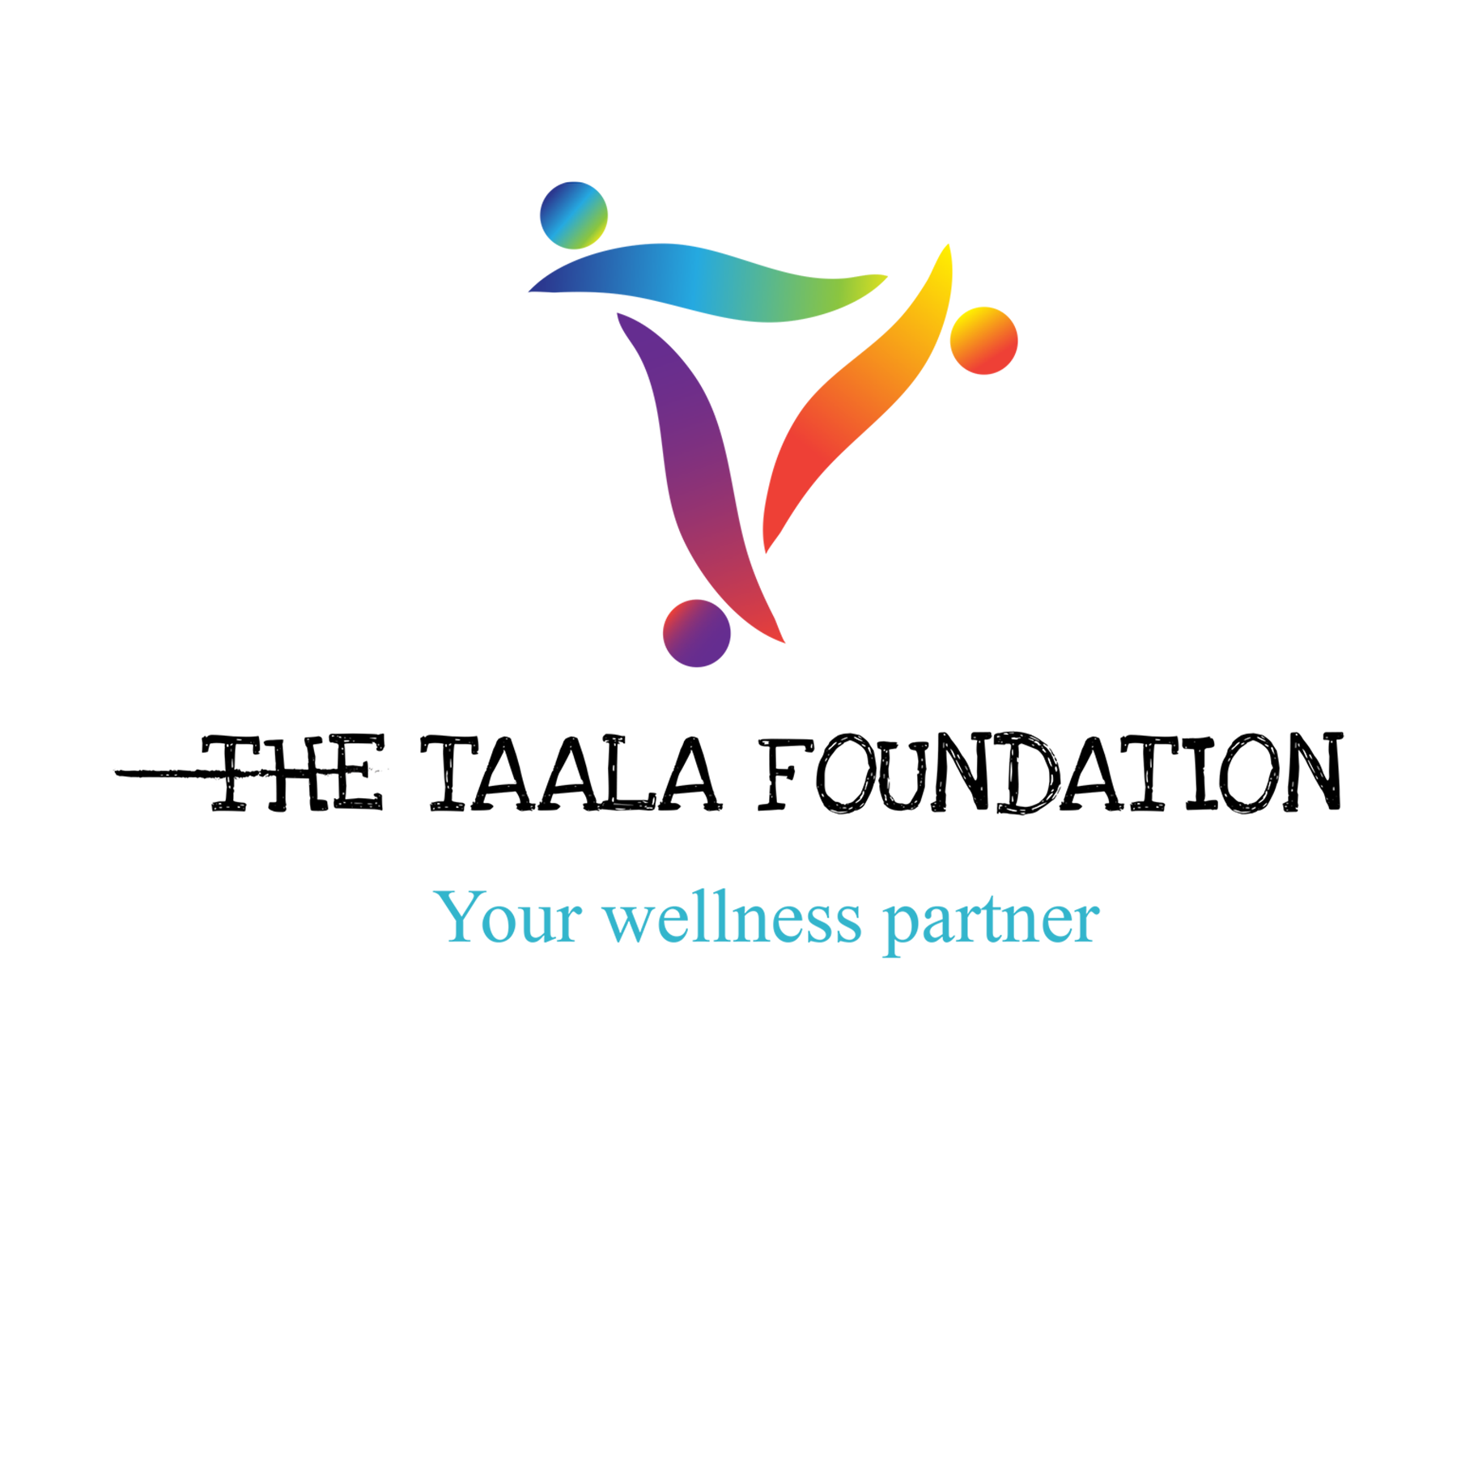TW
SEXUAL RIGHTS LITIGATION NETWORK LAWYERS’ APPLICATION FORM

The purpose of this form is to enable The Taala Foundation and ISLA to assess your understanding of strategic litigation and sexual rights. This will enable us to assess your suitability to be part of the SXLN network chapter in Uganda. Interested legal practitioners are invited to complete this form with as much detail as possible.

BACKGROUND

The Taala Foundation is a registered entity working to bridge the gap in access to wellness support for gender and sexual diverse people in Uganda primarily through Mental Health Promotion and Education. We view wellness as the evolving process of achieving physical, mental, social, intellectual, spiritual, and occupational wellbeing; and thus, we develop our robust programs recognizing those various aspects of wellness. Overall, our work aims at fostering greater levels of wellbeing, dignity, tolerance, respect, and acceptance for gender and sexual diverse people within the broader society.

The Initiative for Strategic Litigation in Africa (ISLA) is a Pan-African and feminist initiative which engages the rule of law within African domestic and regional courts to advance sexual and women’s human rights. We believe that strategic litigation can reframe understanding of entitlements before the law, challenge legal discourse on human rights violations, hold States and other duty bearers accountable to violations of human rights (especially those grounded in gender and sexualities), and develop new norms. Our work is also based on the belief that strategic litigation is a powerful tool for social change because it has the capacity to work in multidimensional ways, both within a given context and, critically, across contexts. We highlight positive developments and emphasise cross-learnings from various countries on the continent.

The Sexual Rights Litigation Network (SXLN) aims to build a body of actors that can hold states accountable for violations against persons based on their gender and/or sexuality by nurturing partnerships between movements and lawyers working together on social change through strategic litigation at national, regional, and international level.

The Sexual Rights Litigation Network’s main goals are:
- To build a widely shared strategy and programme of action to achieve SOGIE rights and equality.

- To advance and promote a movement-based strategic litigation agenda to achieve SOGIE rights and equality.

- To contribute to the building and strengthening of LGBTQIA movements.

To contribute towards this kind of empowered collective of actors and movements, the network invests in strengthening the capacity of movements while simultaneously developing a pool of movement lawyers that have a consciousness and responsibility to assist and support litigation. As part of this effort, we are looking for lawyers who are:
- Dedicated to building the capacity and power of oppressed communities.

- Willing to use their legal knowledge, skills, and connections to support community organising and movement-building; and

- Committed to meeting the full array of on-the-ground advocacy needs.

PERSONAL INFORMATION

Name
Email address
Phone number

Organisation / Law Firm (if applicable)
Work Address
Contact information

- What are your academic qualifications in the area of law and or human rights?

- If you have completed a specialised qualification in human rights or constitutional law, please set out the details.

- Does your current work give you the opportunity to practice law in your area of speciality? Describe what this entails?

- How long have you been practising as a lawyer?

  - ☐2-4 years
  - ☐4-8 years
  - ☐8+ years

LITIGATION EXPERIENCE
- Have you undertaken strategic litigation?
- ☐Yes
☐ No
If yes, what did the strategic litigation involve?

What was your role in the litigation process?

What was the outcome of the process?

- What was the last court decision that you read in the area of sexual rights or human rights in general? Please explain in no more than 300 words what the case was about.

- Describe your experiences working with social movements or activists, if any. Specifically, why did you get involved and what role did you play / are you playing?

- What are some of the common human rights violations faced by LGBTQI+ persons in Uganda?

- What are the main causes of such violations?

- Have you ever consulted or litigated a case involving SOGIE-based human rights violations i.e., violations due to an individual’s sexual orientation and or gender identity?
☐Yes
☐No
If yes, describe your experience.

- What are your thoughts about being the main lawyer on a case involving violations due to an individual’s sexual orientation and or gender identity?
- Do you think lawyers who take on cases involving SOGIE-based human rights issues should be paid more than their usual rate?
☐Yes
☐No
Explain your answer

- What are some of the challenges you foresee in litigating the human rights of LGBTQIA+ persons in Uganda?

